rCANID: read Clustering and Assembly-based Novel Insertion Detection tool
*To whom correspondence should be addressed.
+The authors wish it to be known that, in their opinion, the first two authors should be regarded as Joint First Authors.
Supplementary Material

Tao Jiang⁺, Yilei Fu⁺, Bo Liu & Yadong Wang*

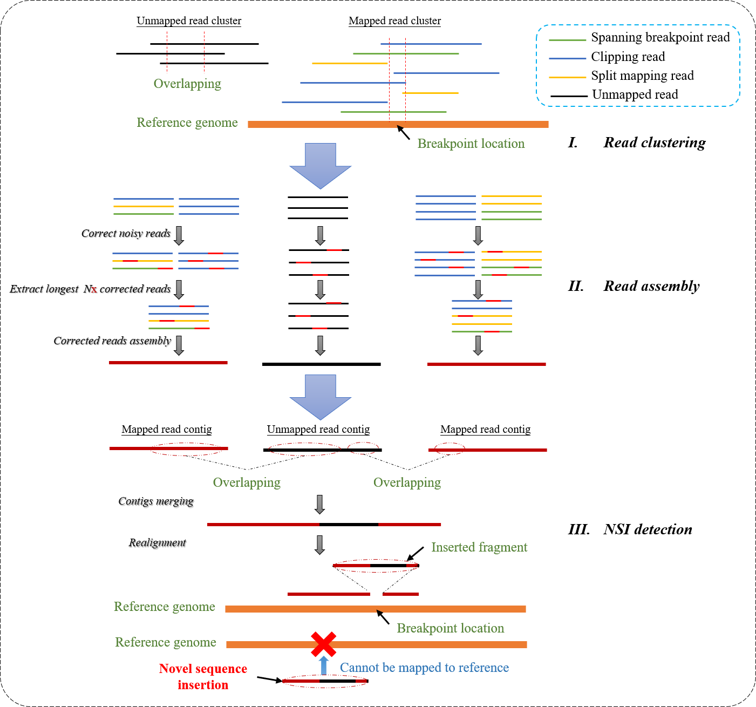
- The overview of rCANID. Three core steps including reads clustering, signal reads assembly and novel insertion detection based on realignment. 1) The first step of clustering will build several highly correlated read clusters and make the assembly more accurate and efficient. 2) The read assembling step will generate high quality contigs and contribute to novel sequence detection. 3) The last step will realign all of the generated contigs and choose unmapped insertion sequence as output.
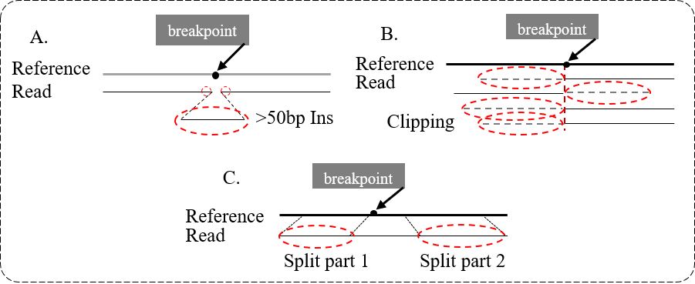
- The definition of signal reads. A) a read considered as signal read when owing more than 50bp insertion. B) a read considered as signal read when including more than 50bp clip. C) a read considered as signal read when holding two split reads alignment.
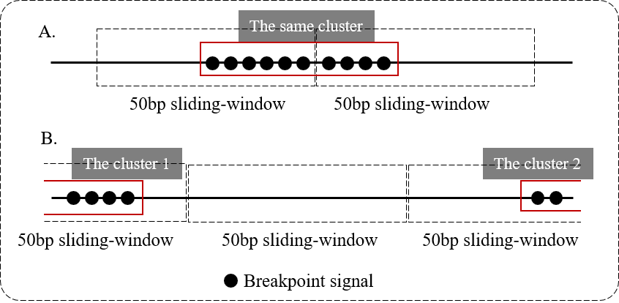
- The Illustration of clustering principle about breakpoints. A) the two neighboring windows will be the same class when both of them own signals and the number of signals are more than 10. B) a window without signals and the two windows connected with will be 2 different classes.
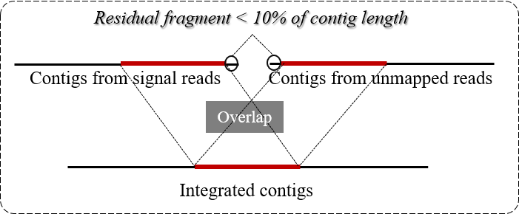
- The Illustration of clustering principle about contigs from mapped and unmapped clusters.

Supplementary Notes
  - Availability of real datasets
  - The availability of the NA12878 PacBio mapped BAM file
http://labshare.cshl.edu/shares/schatzlab/www-data/fsedlaze/Sniffles/NA12878/pacbio/na12878_pacbio_mts_ngmlr-0.2.3_mapped.bam

  - The availability of the NA12878 novel sequence insertion call sets
https://www.ncbi.nlm.nih.gov/dbvar

  - The availability of the reference genome
ftp://ftp.1000genomes.ebi.ac.uk/vol1/ftp/technical/reference/phase2_reference_assembly_sequence/hs37d5.fa.gz

- Availability of simulated datasets
https://drive.google.com/open?id=1TyAfz7BBk-d2VOlpF5nvWRdXVdPcKej
- The availability of softwares
  - The availability of rCANID
https://github.com/hitbc/rCANID

  - The availability of NGMLR
https://github.com/philres/ngmlr

  - The availability of Sniffles
https://github.com/fritzsedlazeck/Sniffles

  - The availability of MECAT
https://github.com/xiaochuanle/MECAT

  - The availability of Minimap2
https://github.com/lh3/minimap2

